**Software Design Specification Outline**

**Introduction**

The aim of this project is to create a web-app that will allow users to create an online business model canvas.

“The Business Model Canvas is a strategic management template for developing new or documenting existing business models. It is a visual chart with elements describing a firm's value proposition, infrastructure, customers, and finances.”

Scope:  
-A user will be able to create a user account.  
-With a user account canvas pages can be created and will be linked to the user account.  
-Canvas information must be storable and retrievable.  
-User interface must be simple and functionality must be obvious at a glance.  
-Webpages must load at a reasonable speed. This will require database access to be efficient.  
-Accounts made on the website must be secure and a user must have the option of withholding some information within their canvas from the public.

**System Design**

**Design Overview**

The system will require a sleek and interactive front-end. This will be coded in html, css and javascript. The use of several javascript libraries such as jquery and json will also necessary.  
The back-end will be programmed with MySQL and PHP. XAMP and PHPMyAdmin are tools that will be sued to create and view the database.

System Design Models

Use case:

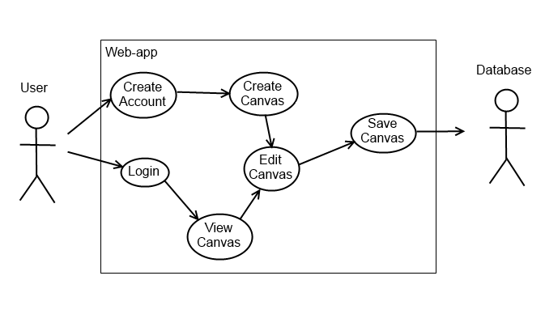

**Page Layout and Database Requirements:**

Sections within the canvas must be able to contain the following information and likewise a table must exist to store that information.

**1. Customer Segment (Product-Market Fit)**

* Customer Demographics
  + Age/sex/finances/etc…
  + Industry/size/department/etc…
* Customer Context
  + User/influencer/decision maker/etc…
* **Customer Archetypes** 
  + **Personas of customer – could be automated from demographics/context section**
* Tool Features (Surveys/communication/etc…)

**2. Value Proposition (Product-Market Fit)**

* Pains (What problems does the product/service solve?)
* Gains (What benefits does the product/service provide?)
* Features (How do the features of the product/service provide value described above?)
* Competitors (What are your advantages over competitors?)
  + Unfair Advantage
* Product (What is the whole product?)
* Elevator Pitch
* **Tool Features** (Share)

**3. Customer Relationships**

* Virtual/Physical (How do customers find you?)
  + Online/Mobile
* Get (How do you find customers?)
  + Paid
    - PR/advertising/trade shows/webinars/email/search engines/Sales team
  + Free
    - Publications/conferences/blogging/social media/word of mouth
* Keep (How do you maintain customers?)
  + Personal Assistance/Dedicated Personal Assistance/Self Service/Automated Services/Communities/Co-creation
* Grow (How do you sell more to existing customers?)
  + Improved features/new features
* **Lifetime value vs. Acquisition cost: dedicated tool**

**4. Distribution Channels (Product-Channel Fit)**

* Digital/Physical (How do you sell to your customers?)
* Digital
  + Website/ecommerce/app platform store/social commerce/flash sales
* Physical
  + OEM/value-added reseller/direct sales/re-distributors
* **Tool Features (Channel economics)**

**5. Revenue Model**

* Market Type (What is your market?)
  + Mass Market/Niche Market/Segmented Market/Multi-Sided Market
* Total Available Market (How big is the whole market?)
* Total Serviceable Market (How big is your target market?)
* Strategy
  + Structure (Cost driven/Value driven)
  + Revenue streams (Asset sale/usage fee/subscription /renting/licensing/advertising)
* Pricing (Prototype/MVP/Start-up/Scale-up)
  + Fixed
  + Variable
* **Tool features - Unit Economics**

**6. Key Partners**

* Sector
  + Industry/Academia/Government
* Relationship
  + Strategic alliance/joint venture/traffic partners/Co-opetition/joint business development/Suppliers (outsource-direct)/Financial support
* Resource
  + Time to market/broader product offering/capital/unique know-how/access to new markets

**7. Resources (Product-Network Fit)**

* Financial
  + Friends/Family/Crowdfunding/Venture Capital/Corporate Partners/Government Grants (Financing Credit)
  + Venture Capital/Corporate Partners/Government Grants/Bank Loans (lease-line)/Factoring/Vendor Financing (Operating Credit)
* Human
  + Mentors: Advance personal success
  + Advisors/Consultants: Advance company success
  + Employees: Create success
* Intellectual
  + Trademarks
  + Copyright
  + Trade-secrets
  + Contracts
  + Patents
  + Prototype
* **Tool Features – Human resources network/Graduate skills network**

**8. Key Activities (Product-Model Fit)**

* Product/Service Development
* Raising Capital
* Team Building
* Channel Development
* Customer Acquisition

**9. Costs**

* Fixed Costs
* Variable Costs
* Funding Requirements
* **Tool features - Unit Economics (Potentially with NumberKrunch)**

**10. MetaSWOT**

* Questions on overall business model
* Hypothesis Testing